Relationship Types

Relationships

•Being able to identify the relationships between entities makes it easier to understand the connections between different pieces of data.

•Relationships help you see how different parts of a system affect each other

•For example, the entities STUDENT and COURSE are related to each other.

•To accurately model the business, the relationships between entities are as important as the entities themselves.

Understanding Relationships:

•Represent something of significance or importance to the business

•Show how entities are related to each other

•Exist only between entities (or one entity and itself)

•Are bi-directional

•Are named at both ends

•Have optionality

•Have cardinality

What is Optionality in a Relationship

•Relationships are either mandatory or optional.

•Consider the two entities EMPLOYEE and JOB.

•Based on what you know about instances of the entities, you can determine optionality by answering two questions:

•Must every employee have a job?

–In other words, is this a mandatory or optional relationship for an employee?

•Must every job be assigned to an employee?

–In other words, is this a mandatory or optional relationship for a job?

What is Cardinality in a Relationship?

•Cardinality measures the quantity of something.

•In a relationship, it determines the degree to which one entity is related to another by answering the question, “How many?

•For example:

–How many jobs can one employee hold? One job only? Or more than one job?

–How many employees can hold one specific job? One employee only? Or more than one employee?

•Note: The cardinality of a relationship only answers whether the number is singular or plural; it does not answer with a specific plural number.

Optionality and Cardinality Examples:

•Each EMPLOYEE must hold one and only one JOB

•Each JOB may be held by one or more EMPLOYEE

•Each PRODUCT must be classified by one and only one PRODUCT TYPE

•Each PRODUCT TYPE may classify one or more PRODUCTs

Representing Relationships

**One-to-Many (1:M) Relationships**

•The various types of 1:M relationships are most common in an ER Model.

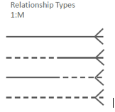

•An example.

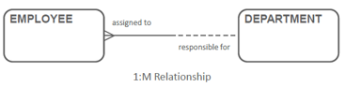

***Many-to-Many (M:M) Relationships***

•The various types of M:M relationships are common, particularly in a first version of an ER model.

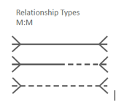

An example

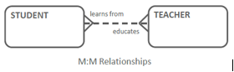

•In later stages of the modeling process, all M:M relationships will be resolved, and disappear.

***One-to-One Relationships For Roles***

•Usually you will find just a few of the various types of 1:1 relationships in every ER model.

•Mandatory at one end of the 1:1 relationship commonly occurs when roles are modeled.

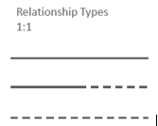

An example

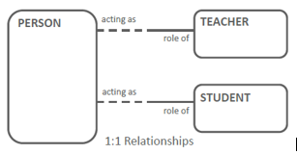

***One-to-One Relationships For Processes***

•1:1 relationships (of all three variations) also occur when some of the entities represent various stages in a process.

An example

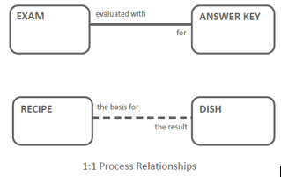

***Redundant Relationships***

•A redundant relationship can be derived from another relationship in the model.

•In this example, you can derive the relationship from PERSON to COUNTRY from the other two relationships (COUNTRY to TOWN, TOWN to PERSON), so you should remove the direct relationship from COUNTRY to PERSON .

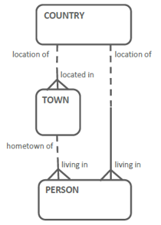

•However, be careful of concluding that a relationship is redundant based on the structure alone.

•Read the relationships to check.

•The ERD shown here does not reflect a redundant relationship.

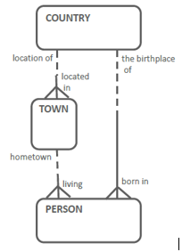

***Business Scenario - Recursive relationship***

•A relationship can join one entity to itself.

•Examine the following scenario:

–“We need to keep track of our employees and their managers. Every employee has one manager, including the managing director who manages him/herself. Each manager can manage several employees.”

•Since managers are also employees, both are listed in the same entity: EMPLOYEE.

***Relationship***

* Each EMPLOYEE may be managed by one and only one EMPLOYEE
* Each EMPLOYEE may manage one or more EMPLOYEEs

